Auxiliary Bridge Program Training Manual

The purpose of this document is to provide information to Auxiliary members regarding the observation and reporting of discrepancies on bridges under Coast Guard jurisdiction in the United States. The main areas of functionality that are examined when observing a bridge are:
- Navigation lights
- Fendering system
- Channel obstructions
- Regulatory signs and tide clearance gauges
- Bridge signaling and operation

Until 1981, Coast Guard personnel annually inspected bridges over US navigable waters. In May of 1981 however, the Coast Guard discontinued its program of doing annual inspections of navigational lighting on bridges over navigable waters to reduce operating costs. While these periodic inspections were useful in achieving a high level of compliance with bridge laws, they were not required by law, and were expensive to perform. It was determined that an adequately high level of compliance could be achieved by enforcement procedures in response to reports or complaints of violations.
Therefore, the Coast Guard is now relying on mariner notification to discover discrepancies to bridge lights and fender systems as well as other hazardous bridge conditions.
Through the Memorandum of Understanding (MOU) between the Coast Guard and the C.G. Auxiliary, the Auxiliary renders important assistance to the Coast Guard’s Bridge Administration Program to observe and report on discrepancies on US bridges. These reports allow the Coast Guard’s bridge office in each District to order needed repairs to keep bridges in conformance with federal regulations.

The Auxiliary Bridge Program
The Auxiliary Bridge Program has two main parts:
- Bridge Discrepancy Reports
These are reports of problems observed by any BQ Auxiliary member, whether observed while out on patrol, during a day out fishing, or even while just passing a bridge while ashore. Since these reports will sometimes come in from a member with no formal training in bridge regulations, all districts will funnel these reports through a quality control process, having them reviewed by an AV qualified reviewer before they are passed up to the CG Bridge Office.
- Annual Bridge Surveys
Bridge Surveys are a comprehensive review and report of a bridge done by certified Aids Verifiers, checking to see that the bridge meets the requirements of its Coast Guard permit.

Bridge Discrepancy Reporting
All BQ Auxiliary members are encourage to note any discrepancies on bridges that they pass, and report these discrepancies to the Coast Guard via their District’s bridge program reporting channel. These reports allow the staff at the Coast Guard Bridge Branch to contact the bridge owner and get the discrepancy fixed.
- Coxswains should keep Bridge Discrepancy forms on their facilities to record discrepancies as soon as they are seen. Discrepancies should be reported within 24 hours of the observation, using your district’s bridge report routing.
- All District NS staff should set up a discrepancy report routing process to ensure that all bridge discrepancy reports are reviewed by and AV qualified reviewer for accuracy prior to being forwarded to the CG Bridge Office.

What to Report
The C.G. is only interested in bridge problems that affect marine navigation, not those that only affect the road or rail traffic that uses the bridge. We report on lighting, fenders, operations, or obstructions in the channel. We don’t report problems with the roadway, road signs, rail road tracks, or the bridge structure, nor any other bridge issues that don’t affect marine navigation.
Historically, the largest number of bridge discrepancies reported have been:
  - Extinguished lights
  - Damaged fender systems
  - Improper lights & signs
  - Obstructions in the channel (debris, hanging cables, damaged fenders)
  - Improper operation by the owner/bridge tender:
    - Not responding to radio calls
    - Delaying opening of the draw
    - Not adhering to 33CFR117b special rules
In reporting a bridge discrepancy, a picture speaks a thousand words. Other than extinguished lights, all bridge discrepancy reports must also contain photographs of the discrepancy
Bridge Survey Report
A Bridge Survey Report is a detailed review of bridge lights, signs, fenders, gauges & prior discrepancy reports to see if bridge is in compliance with their C.G. bridge permit. Bridge Surveys are normally done annually.
Since a proper bridge survey must see the bridge lights after dark, as well as the fender system at low tide during daylight hours, a proper bridge survey normally takes at least two visits to the bridge (daytime and nighttime) to be done properly.

Photographs
All Bridge Surveys, as well as all discrepancy reports for other than extinguished lamps require the inclusion of photographs of the bridge, and detailed photographs of any problems found. This will not only provide quality control to the program, but it will greatly enhance the information being forwarded to the C.G. Bridge Office. As such, a camera (preferably a digital camera) is a required tool for Aids Verifiers who conduct Bridge Surveys, and members reporting discrepancies.
While digital photos are preferred, paper photographs are also acceptable. Due to security concerns around some bridges, Aids Verifiers who are doing Bridge Surveys should be in uniform when talking pictures of any bridge. In addition, photographs for inclusion with Bridge Surveys should only be taken by Aids Verifiers who have been assigned to duty to do a survey on a specific bridge. This will prevent multiple members doing surveys on one bridge, while other nearby bridges remain uncovered.

Two Broad Classifications of Bridges
For the purpose of describing bridge regulations, all bridges fall into two main categories:
- Fixed Bridges – bridges that are not capable of moving or opening, and
- Draw Bridges – bridges that can move or open to allow vessels to transit. This category includes bascule bridges, swing bridges, vertical lift bridges, pontoon bridges and retractable bridges.

Bridge Lighting
Discrepancy reporting requires observers to have a basic knowledge of some requirements governing bridge lighting and bridge lighting recommendations. The federal regulations governing bridge lighting can be found in 33cfr118. The sections below are excerpts from 33cfr118.
- Lighting during bridge construction. The district commander, having jurisdiction over the area in which the bridge is being built, will prescribe lights including temporary lights and other signals to be displayed for the protection of navigation. When the construction of a bridge is completed, permanent lights and other signals approved by the district commander -for the completed bridge shall be displayed.
- Periods of operation generally requires that lights be displayed from sunset to sunrise and at other times when the visibility is less than one mile. Operators shall not be required to exhibit prescribed lights during seasons when vessels are unable to navigate in the vicinity of the bridge.
- Lights required by the regulations shall be of sufficient candlepower as to be visible against the background lighting at a distance of at least 2,000 yards on 90 percent of the nights of the year. They are located as prescribed, with colors and arcs of visibility as specified.

Fixed Bridges
- Each fixed bridge span over a navigable channel is lighted so that the center of the navigable channel under each span is marked by a range of two green lights. The margin of each channel is marked by a red light provided that, when a margin of a channel is limited by a pier, only the pier lights prescribed shall mark that channel margin. The green lights show through a horizontal arc of 360º; and are mounted just below the outermost center edge of the bridge span structure. Each red light shall show through a horizontal arc of 180º. Red lights are to be securely mounted just below the outermost edge of the bridge span structure to show 90º on either side of the bridge on a line parallel to the axis of the channel (i.e., the light points toward approaching vessels).
- Pier lights are used when the navigable channel extends from pier to pier or when piers are located within the navigable channel. The end of each such pier is lighted with a red light, showing through a horizontal arc of 180º. This light is fastened at the end of the pier as low as practicable (but not lower than 2 feet above navigable high water) to show 90º on either side of a line parallel to the axis of the channel (i.e., pointed toward approaching vessels).

- The main channel of fixed bridges having two or more spans over a navigable channel shall have additional markings over the main channel span. This span will be marked with a set of three white lights arranged in a vertical line directly above the green light marking the main channel span. Each white light will show through a horizontal arc of 180º, and is to be mounted so that 1/2 of the horizontal arc shows on either side of a line parallel to the axis of the channel. These three white lights are mounted on the bridge structure and spaced as nearly to 15 feet apart vertically as the structure of the bridge permits, with a minimum spacing of 7 feet. The lowest white light in the line of three lights is placed not less than 10 nor more than 15 feet above each green light on the main channel span.

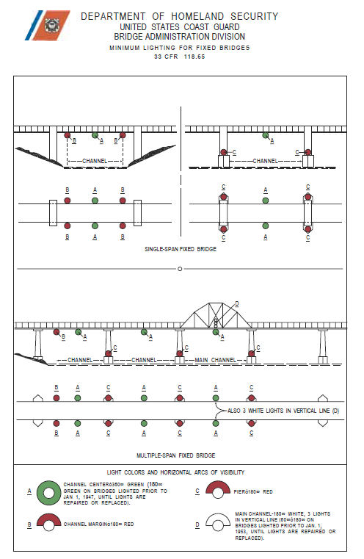

Lights on Swing Bridges
- Each swing span of every through swing bridge is lighted with three lanterns so that when viewed from an approaching vessel, the swing span, when closed, displays three red lights on top of the span structure, one at each end of the span on the same level and one at the center of the span not less than 10 feet above the other two lights, and when open for navigation display three green lights on top of the span structure in a line parallel to and directly above the long axis of the span, one at each end of the span on the same level, and one at the center of the span not less than 10 feet above the other two lights. Each lantern shows through alternate red and green horizontal arcs of 60º each, the axis of adjacent arcs are 90º from each other; each light is mounted with the axis of the green arcs parallel to the long axis of the swing span.

- Swing span lights on deck and half-through bridges have each swing span of every deck half-through, girder, or similar type swing bridge, lighted with four lanterns so that when viewed from an approaching vessel the swing span (when closed) displays one red light at each end, and, when open to navigation, displays two green lights from each end. Each lantern shows through one red and two green horizontal arcs of 60º each, the axis of each green arc is 90º from the axis of the red arc; each light is mounted at the floor level of the span with the axis of the red light normal to the long axis of the swing span and so that the red light is visible from an approaching vessel when the span is closed.

- Pier Lights on every swing bridge are lighted so that each end of the piers adjacent to the navigable channel (draw piers) or each end of their protection piers, (draw pier protection piers) and each end of the piers protecting the pivot pier (pivot protection pier) is marked by a red light. Each of these lights show through a horizontal arc of 180º and is mounted as low as practicable below the floor level of the swing span to show 90º on either side of a line parallel to the axis of the channel so as to be visible from an approaching vessel.

- Axis lights on every swing bridge are lighted so that the intersection of the bridge axis with each side of the pivot pier and the channel side of each draw pier which has a protection pier, is marked by a red light provided that, if the draw and draw protection piers are straight along their channel faces, these lights are not required. Each such light shows through a horizontal arc of 180º, and is mounted on the navigable channel face of the pier as low as practicable below the floor level of the swing span to show 90º either side of a line normal to the axis of the navigable channel so as to be visible from an approaching vessel.
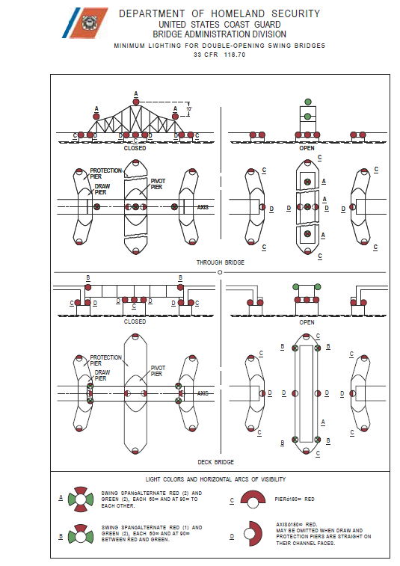

Lights on Single-Opening Retractable Drawbridges
Bridges of the folding, pontoon and similar type single-opening drawbridges are lighted with two lanterns so that when viewed from an approaching vessel the draw span, when closed, displays two red lights, one at each end of the span, and when open to navigation displays two green lights, one at each end of the span. Each lantern shows alternate red and green horizontal arcs of 60º each, the axis of adjacent arcs is located 90º from each other; each lantern is mounted 15 feet above the roadway with the axis of the green arcs parallel to the long axis of the swing span.

Pier or abutment lights; every swing bridge is lighted so that lights are mounted at the end of each pier, abutment or fixed portion of the bridge adjacent to the navigable channel through the draw, or each end of the protection piers for such piers, abutments, or fixed portion of the bridge is marked by a red light. Each red light shows through an arc of 180º, and is mounted on the pier, abutment or fixed portion of the bridge, as low as practicable to show 90º on either side of a line parallel to the axis of the Channel so as to be visible from an approaching vessel.
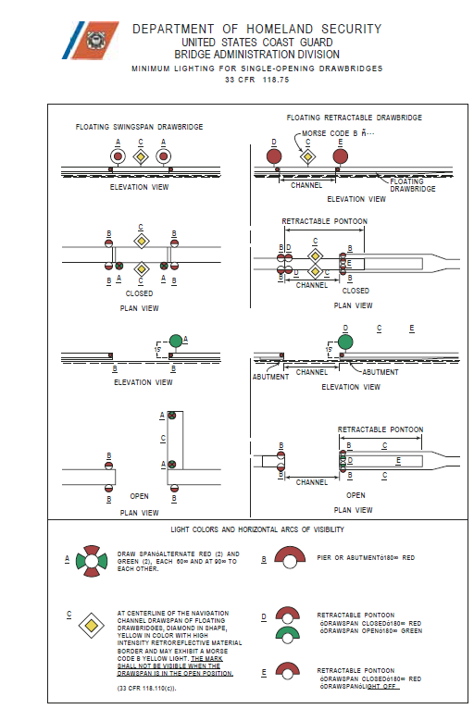

Lights on Bascule Bridges.
Each lift span of every bascule bridge is lighted so that the free end of the span will be marked on each side by a green light which shows only when the span is fully open and by a red light which shows for all other positions of the lift span. Each red and each green light shows through a horizontal arc of 180⁰. The lighting apparatus is securely mounted to the side of the span so that the light will show equally on either side of a line parallel to the axis of the channels, so that they are visible from an approaching vessel.
- The outermost side of each outer span of every bascule bridge with parallel multiple lifts are lighted as prescribed for individual spans; the lights are controlled so that the green lights will be displayed only when all spans are open for navigation. The inner sides of each outer lift span and both sides of each inner lift span of such bascule bridge shall be lighted by red lights for all positions of the lift span. These lights shall have the same arcs of illumination and shall be mounted as described in the preceding paragraph.

- Pier lights. Every bascule bridge is lighted so that each end of every pier, or protection pier where provided, in or adjacent to the navigable channels under the lift span or spans, is marked by a red light. Each such red light shows through a horizontal arc of 180⁰, and is mounted as low as practicable on the end of the pier, or protection pier, to show 90⁰ either side of a line parallel to the axis of the navigable channel so as to be visible from an approaching vessel.

- Axis Lights. Every bascule bridge which has at least one pier provided with a protection pier is lighted so that the intersection of the long axis of the lift span with the channel side of each pier, or protection pier, is marked by a red light; provided, that if all such piers and protection piers are straight along their channel faces, these lights are not required. Each such red light shows through a horizontal arc of 180⁰ and is mounted on the navigable channel face of the pier as low as practicable to show 90⁰ on either side of a line normal to the axis of the navigable channel so as to be visible from an approaching vessel.
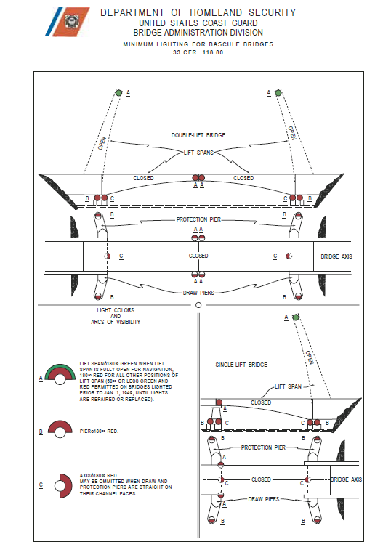

Lights on Vertical Lift Bridges.
The vertical lift span of every vertical lift bridge is lighted so that the center of the navigable channel under the span is marked by a range of two green lights when the vertical lift span is open for navigation, and by one red light on each side for all other positions of the lift span. The green lights show through a horizontal arc of 360⁰; they are securely mounted just below the outermost edge of the bridge span structure so as to be visible from an approaching vessel. Each red light shows through a horizontal arc of 180º, and is securely mounted just below the outermost edge of the lift span to show 90º on either side of the line parallel to the axis of the channel so that only one such light is visible from an approaching vessel.

- Pier lights. Every vertical lift bridge is lighted so that each end of every pier in or adjacent to navigable channels under the lift span, or each end of every protection pier when provided, is marked by a red light. Each such light shows through a horizontal arc of 180º, and is mounted as low as practicable on the end of the pier, or the protection pier, to show 90º on either side of a line parallel to the axis of the navigable channel so as to be visible from an approaching vessel.

- Axis lights. Every lift bridge which has at least one pier provided with a protection pier is lighted so that the intersection of the lift span axis with the channel side of each pier adjacent to the navigable channel is marked by a red light; provided, that if every such pier, or protection pier, is straight along its channel face, these lights are not required. Each such light shows through a horizontal arc of 180º, and is mounted on the navigable channel face of the pier as low as practicable to show 90º on either side of a line normal to the axis of the navigable channel so as to be visible from an approaching vessel.

- Lights on sheer booms, isolated piers, and obstructions not part of the bridge or bridge approach structure show a white or green light if kept on the left of vessels approaching from seaward, and show a white or red light if kept on the right of vessels approaching from seaward. For rivers the same rule applies, white or green lights are shown from the right descending bank; white or red lights to be shown from the left descending bank. The color of the light and its characteristics (fixed, flashing, occulting, etc.) as determined by the district commander, and is shown on charts.
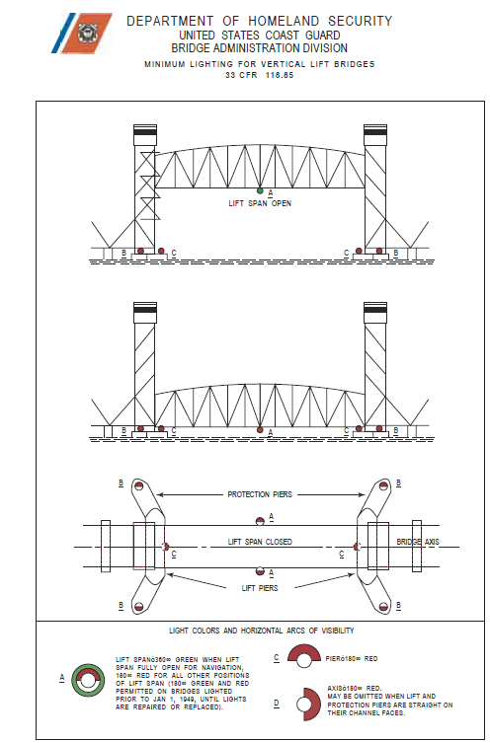

Day Marks and Lateral Lighting on Bridges

Some bridges are required to have lateral markings, that is, red and green marking similar to color marking on lateral buoys, that are intended to show the mariner which channel to pass through.
If a bridge carries the red and green lateral marks to mark the navigable channel, then fixed yellow lights shall be used to mark the adjacent piers, and the centerline of the channel shall be marked with the standard lateral system safe water mark - and occulting white light, instead of the lights described earlier in this document.
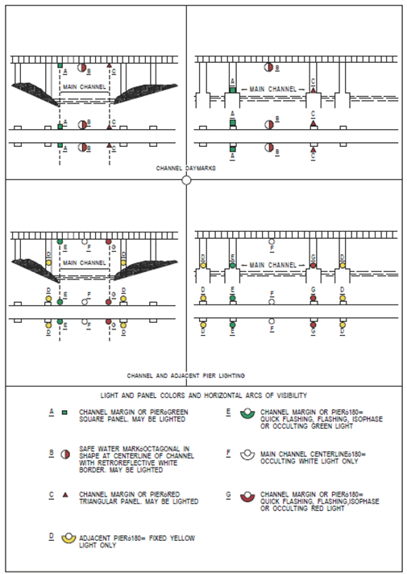

Reporting Bridge Lighting Systems Discrepancies
When reporting discrepancies observed on a bridge, it is important to fully and accurately describe the problem, so that someone reading the report can get the correct reading of what the actual problem is. Words like “left” and “right” should be avoided since they are ambiguous and their perspective changes with the observer’s position. Terms like “upstream west side” or “downstream north east” are far more descriptive and unambiguous.
All lighting discrepancies must be observed between legal sundown and legal sunup before a discrepancy report is filed with the Coast Guard.
When reporting a problem with a light, always report the type of light and the location of the light (e.g., “the upstream west pier light”). While some bridges will burn some of their lights during daylight hours, an observation made during daylight hours may not be used as the basis for filing a light discrepancy report.
If reporting a light that is extinguished, identify the exact light or lights as follows:
"Red channel margin light on the downstream east side is extinguished, or “West and top swing span lights on upstream side are extinguished."

If a light or lights are not functioning as required in order to indicate whether the bridge span is open or closed, report them as:
"Lift span center light on the downstream side does not shift from red to green when the span is in the fully raised position”, or “Swing bridge center light does not shift from red to green when the span swings to the fully open position. Green sector of upstream light appears to be shielded or painted out."

If a light or lights are extinguished or otherwise damaged due to vandalism, identify them as:
"Lens on west pier light on downstream side is showing white light instead of red light because the lens is missing."

Fender System Problems
Fender system problems can pose a hazard to vessels. Any problem with the fenders that could allow a vessel to contact concrete or metal, or projects obstructions into the channel should be reported as a discrepancy. This includes severely deteriorated fendering that no longer properly protects the bridge.
All fender discrepancies should always include a photograph of the problem(s).
Fender problems that should be reported include:
- Steel plates or protruding steel bolts that can puncture vessels and cause sparking that can cause fires.
- Bolts, washers, steel corner plates, etc. (These should be countersunk or placed behind the fender wales. If not possible, then suitable cover must be placed, over the steel to prevent metal-to-metal contact between the vessel and fender during transit.)
- Debris trapped by the fender system that protrudes into the channel
- Broken fendering that no longer protect the bridge.
- Broken fendering that protrudes into the channel
- Severely deteriorated fendering due to age, allusion or fire.

Observing Fender Problems
Vertical versus horizontal sheathing and wales - (Placement and spacing of sheathing and wales is important because improper or inadequate arrangement of same can contribute to an accident as much as no fender at all. Wales are the horizontal components of the fender system. It is important that the wales sufficiently cover the full range of the tide to prevent vessels from riding over the fender or catching its gunwale on the bottom of the lower wale. Similarly if the wales are too far apart, a vessel listing or rolling a little can hang up on the fender and damage the fender and/or the vessel itself
Debris collection - If the fender system lends itself to debris collection, submerged and surface hazards can exist that the mariner may not see until it is too late to avoid them.
Protrusion of dolphins on the side of fender - The side or face of a fender system should not have any protrusions or dolphins because these are areas where the forward rake of a barge or the bow of a vessel can catch.
Nose and pier dolphins and pier protection cells may be used as an additional measure of protection to bridge piers where adequate horizontal clearance is available and there is little possibility of contact with the pier except when a vessel loses steering control. Dolphins or pier protection cells are being used to supplement fenders and satisfy various waterway requirements such as ice protection, supporting of lights and communications platforms.

Particular fender problems to watch for include the following:
- Fender Strength - inadequate versus adequate; dilapidated versus repaired; machinery unprotected versus protected; swing bridge ends unprotected versus protected; not designed for type of vessels using the bridge; fender not high enough; and bascule leaves overhanging the fenders.
- Cables hanging below bridge structure.
- Nets and scaffolding hanging below bridge structure.
- Pier protection cells, planks or coatings missing, steel sheathing protruding, cell damaged.
- Pile dolphin clusters broken off, leaning into channel, debris protruding from cluster, or top of clusters wrapped with other than wire cable.
- Ladders, platforms, rails or other steel objects protruding into channel

Reporting Bridge Fender System Discrepancies
When reporting fender discrepancies observed on a bridge, it is important to fully and accurately describe the problem. Words like “left” and “right” should be avoided, while terms like “upstream west side” or “downstream north east” are far more descriptive and unambiguous.
All fender discrepancy reports must be accompanied by a photograph that clearly shows the discrepancy when the report is filed.

Conducting the Survey
Unlike Bridge Discrepancies that can be reported by any member, Bridge Surveys are conducted only by certified Aids Verifiers.
Bridge surveys are only done when specifically requested by the NS chain, via your SO-NS. Only Aids Verifiers who are assigned to duty by their SO-NS in this manner may conduct a bridge survey. While the bridge survey program is constrained to the assignment to duty requirement specified above, any BQ member who spots a discrepancy on a bridge at any time is encouraged to submit a Bridge Discrepancy form to report the problem.
A bridge survey requires at a minimum, two separate visits to a bridge. One must be during daylight hours near low tide when the clearance gauges and fender system can be seen, and one should be at night when the bridge lights can be checked.
The following sections describe the information needed on a Bridge Survey report.

Bridge Identification
Enter the official name of the bridge as listed in the Coast Pilot , as well as any local names for the bridge.
Enter the latitude and longitude of the bridge as determined either with a GPS that is on or near the bridge (accuracy is not important, as long as you are within 100’ of the bridge), or as determined from a nautical chart.

Bridge Classes & Bridge Numbers
To keep track of information regarding the bridges and the results of surveys that have been done, the Aids to Navigation team has developed a PC based data base system. This data base will use a Bridge Number as an ID to organize the bridge data. This number will be initially assigned by data base system.
Aids Verifiers who do Bridge Surveys, but don’t know the number for a given bridge should leave the field blank. When doing a follow up survey where a form with the bridge number on it has been supplied by the ATON team, the Verifier should include the bridge number on the new report.
Check that the Waterway referenced on the Bridge Report is correct. If the bridge is at a waterway junction, show the adjoining waterway’s name. Each bridge lists its location on the waterway, starting at the mouth or start of the waterway toward seaward. Is this referenced correct? Indicate miles above mouth if known.
List the towns on either side of the bridge. If you can verify the owner of the bridge, check this against what the Coast Pilot says, and report any differences.
Each bridge will be traced as a member of one of four classes:
- Class 1 - bridges that span waters used by ocean going ships. The George Washington Bridge and the Verrazano-Narrows Bridge are Class 1 bridges.
- Class 2 - bridges that have tug and barge traffic, but no ocean going ships. The Atlantic Beach Bridge or all of the Harlem River bridges would be Class 2 bridges.
- Class 3 - bridges that have recreational traffic, but not barges or ocean going ships. The Atlantic Highlands bridge would be a Class 3 bridge.
- Class 4 - bridges spanning waters only used by row boats or small outboard powered boats. No marine facilities are located above a Class 4 bridge. Almost all Class 4 bridges are fixed bridges or de-commissioned draw bridges over small creeks. Do not report on these bridges unless specifically requested.

Enter the bridge class on the survey form in accordance with the descriptions above. If you disagree with the classification that has already been made for a bridge, that’s OK – just note that in the comments section, along with your reason why you think it should be re-classified.

Light Survey
Complete a light survey each time that you check a bridge. Always check lights at night to see that they are working properly. Some bridge lights are always on.
Check and report the number of each type of light that is observed on the bridge.
Count the lights on both sides of the bridge.
- Indicate whether the lights are correctly placed on the bridge.
- Indicate whether the lights are the proper color.
- Indicate whether the lights are visible for one nautical mile.

Center Channel Lights
- Marks the center of the navigable channel on both upsteam and downstream sides of the bridge. Commonly found on Fixed Bridges.
- Should appear as pair 360-degree green range-lights beneath the span or lip of the bridge.

Margin of Channel Lights – Lift Span Lights
- Mark the limits (edges) of the navigable channel on one or both sides of the bridge.
- Will only be present if the channel does not extend to the bridge pier on that side.
- Should be 180-degree red lights that shows facing at the flow of traffic as you approach the bridge in the navigable channel.
- Are hung just below the lip of the span to mark the level of low steel.

Pier Lights
- Used to mark piers attached to the bridge.
- Should be 180-degree red lights fixed to the piers. Lights show forward toward the flow of traffic as you approach the bridge in the navigable channel.

Axis Lights
- Mark any turn in a pier line that is attached to a bridge. Often used to mark the centerline of the bridge across the channel of a vertical lift or swing bridge.
- Should be 180-degree red lights fixed to the piers. Lights always show inward across the navigable channel.

Moveable Span Lights
- Found on draw, swing, retractable, lift, and bascule bridges in a combination lantern in various configurations of red and green light fixtures.
- Shows red when the bridge span is closed or moving, and shows green when the bridge span is opened.

Preferred Channel Lights
- Commonly found on bridges with multiple navigable channels.
- Three white lights fixed above the center channel lights are used to indicate the preferred channel.

Fender Survey

Complete a Fender System & Wales Survey each time that you check a bridge.

Wales.
- Must be in good repair.
- No sharp metal or bolts should protrude into channel or be exposed on corners.
- No metal corners.

Protective Piers.
- Must be wrapped with steel cable.
- Nothing can project into the channel from these protective piers.

Obstructions in the channel(s).
- Nothing may be hanging below the lip of bridge’s span. Check the LNM for authorizations for deviation from this rule during periods of repair and reconstruction.
- Sanity check the depth of water in the navigable channel under the bridge and in both approach channels.
- Nothing should stick out of the sides of the bridge wales and piers into the channel.

Signs & Clearance Gauges

Check the Clearance Gauges and Signs on the bridge each time that you check a bridge. Check the Coast Pilot or 33cfr117b to see if signs are required. If there are any special regulations listed for that bridge, a sign with those regulations is required on both sides of the bridge.
If the “Federal Regulations & Special Notes” section found on page 3 of the “Bridge Survey Report ” does not list the text that is in the Coast Pilot, enter it into that section. That will allow the program team to get this text into the data base for future use.

Clearance Gauges on Drawbridges.
- Should be mounted at the right side of the bridge as you face the bridge in the main channel.
- Should be located on both the upstream and downstream side of the bridge.
- Not required and usually not found on Fixed Bridges (only required if listed in Coast Pilot or in 33cfr117b).
- Should be readable for a one-half mile distance – 1,000 yards.
- Must be readable down to the low water mark.

Special Regulation Signs on Drawbridges.
- Normally found on bridges that open to pass maritime traffic.
- Compare the regulations shown on the bridge’s sign with the “Bridge Regulations” shown in the “Federal Regulations & Special Notes” section found on page 3 of the “Bridge Survey Report.”
- Regulatory Signs must be readable and be located on both the upstream and downstream sides of the bridge.
- When a bridge opening requires a phone call to the bridge tender, check that the phone number appears on the bridge’s sign. Call the phone number and validate that it works, but never request an opening as a test.
Comments & Drawings
Any problems that were noted in earlier sections (e.g.., light or fender survey problems), should be described here. Enough detail should be given to paint a verbal picture of what the problem found was, and where it was located. Use full sentences – short three word comments are not useful!
The Bridge Survey Report will get your inspection information to the Coast Guard Bridge Office, but you still need to report your time to AuxData. Remember to submit a Form 7030 Mission Report (Unit/Individual) to report the time spent to get AuxData credit for your work.

