Fish Farms, Fish Traps and Fish Stakes

As you will read below, fish farms not only have special marking requirements but also have NOAA charting rules. As part of your verification, AVs will be required to perform the following checks. Since each fish farm must be permitted by the USACE, it should be charted. Verify the four the four corners of the fish farm with fixes. Compare these locations to the four corner positions plotted on the NOAA chart. Include these fixes as part of your report. Show them in the comments section of your report. Any geographical discrepancies should also be reported to NOAA as a Chart Update Report. Also report when the fish farm is not documented correctly.

The four corners of the fish farm should be marked by Special Purpose aids. These aids should be permitted and be included in the PATON System database. Each lighted aid should be listed and should be verified as individual private aids. Provide photos of these aids.

In some cases, unlighted special purpose aids may be grouped under one PATONS System listing as a number in brackets (2). Sometimes this grouping may show (8 or more). In this situation, obtain fixes for the corners of the fish farm area and just list the number of unlighted private aids marking the farm. When unlighted aid mark the corners of the farm, document them as individual private aids and show the data in the comments section of your report. Photographs the aids marking the corners.

Below is a extract from a NOAA Chart showing the boundaries of a Fish Pen. There are no private aids showing on the chart.
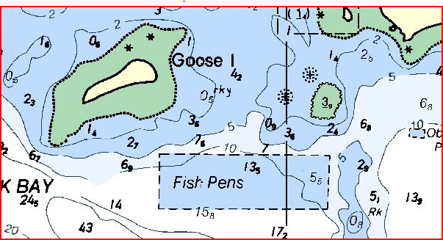

However, the PATON System is calling for 4 lights as is shown below.
1009.00 | 4078 | Goose Island Aquaculture Lights (4) | 44-54-41.000N | 067-02-20.000W
The assumption is that these lights are marking the four corners. In this case, you would verify each of these lighted aids. If they are not marking the four corners of the fish farm, you would also document each corner and check the fix against the charted positions.

Fish Farms | Report the boundaries of fish farms as well as any specials lighting. Report light type, color, characteristics, and height. Fish farms are often lighted with private aids to navigation. These aids are usually special purpose aids, colored yellow and, if lighted, show yellow lights depending on location of the fish pens. Any aid is that is lighted must be permitted, be charted and listed in Light List. Ideally, the four corners of the pen area should be marked. If the pen area is close by a federal channel, the outer two aids near the channel should be lighted. If the owner chooses not to mark the four corners of the fish pen, then they need to permit each and every marker in the area.

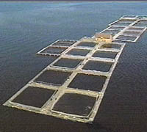
NOTE: Fish farms follow the same permitting rules as Fish Havens and are not permitted to private interests. For liability reasons, they are permitted to municipalities by the USACE-Corp of Engineers. The boundaries are established by the USACE (Army Corps of Engineers) who reports them to NOAA for charting purposes.

Fish Stakes  Submerged Stakes |  | Report visible and submerged stakes located outside of its charted trap area.  Take fixes to define the extent of the fish stake area. Plot the area on a nautical chart.  Indicate whether and how the area is lighted. Provide the light color and characteristics with your report.  Also, report your observations to the local C.G. Unit.  If you suspect submerged fish stakes, survey the area at low tide from a navigable channel or deep water area. Operate with extreme caution near the fish stake areas.
  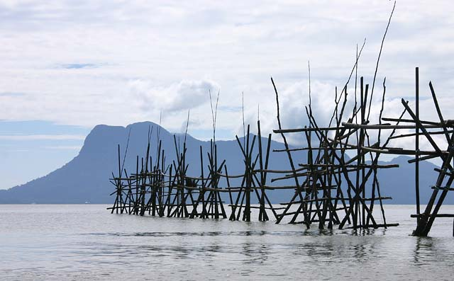
  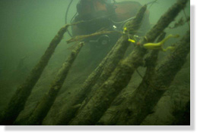

Fish Havens  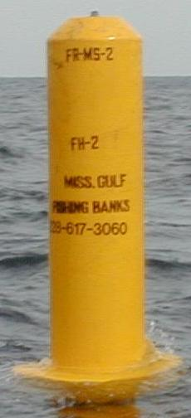 | Report obstructions, lights, fixes of boundary locations of the area blocked or covered by the fish haven. The picture shows a buoy marking a boundary position for the fish haven. Many of these buoys will be private aids. Check the light list for their light’s assigned positions or take the LAT/LON from a nautical chart. Also, submit a report to the local C.G. Unit. Report light colors, characteristics, and rhythms. Fish havens are usually marked with special purpose aids and, if lighted, yellow lights.  Fish havens are not “permitted” to private interests. For liability reasons, the USACE-Corp of Engineers permits them to municipalities. Usually, fish havens are designed to simulate natural reefs and wrecks that attract fish. The reefs are constructed by intentional placement of assorted secondary-use materials and designated fishery habitat, ranging from old trolley cars and barges to scrap building material in areas which may be of very small extent or may stretch a considerable distance along a depth curve; old automobile bodies are a commonly used material. The Corps of Engineers must issue a permit, specifying the location and depth over the reef, before such a reef may be built. However, the reef builders’ adherence to permit specifications can be checked only with a wire drag. Fish havens are outlined and labeled on the charts and show the minimum authorized depth when known.  On a chart, fish havens are tinted blue if they have a minimum authorized depth of 11 fathoms (66 feet) or less or if the minimum authorized depth is unknown and they are in depths greater than 11 fathoms but still considered a danger to navigation.  Be cautious about passing over fish havens or anchoring in their vicinity.

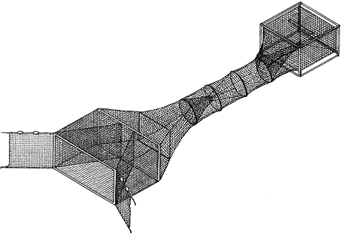 | Fish Trap Areas  Show the limits of the area covered by the fish trap with fixes. Plot them on a nautical chart. Report the light colors and characteristics. Also, report your observations to the local C.G. Unit. If the trap is observable above water, submit photos to prove your report  Fish trap areas are areas established by the U.S. Army Corps of Engineers, or State or local authority, in which traps may be built and maintained according to established regulations. The fish stakes, which may exist in these areas, are obstructions to navigation and may be dangerous. The limits of fish trap areas and a cautionary note are found on the chart.  Most fish trap areas will be marked with lighted private aids (PATONs). These aids will usually be Class II and be charted. Fish trap areas are marked with special purpose aids and, if lighted, with yellow lights. Corrections to the position of these PATONs are made through the LNM-Local Notice to Mariners to NOAA.

