WEB-BASED PRIVATE AID TO NAVIGATION SYSTEM TRAINING GUIDE


United States Coast Guard Auxiliary

Navigation Systems (NS)

WEB-BASED PRIVATE AID TO NAVIGATION SYSTEM
HARBORMASTER

Table of Contents

- Accessing the PATON System- 3 o How to Log On - 3
o User Logon Screen Example.
- How to Register - 3

o PATON Registration Screen Example - 5
- If you forget your Access Code - 5
- Changing your Registration Record - 5
- Preparing a PATON Application – CG 2554 Form - o PATON Logged On Screen Example - 6

o CG 2554 Screen – Header Field Group Example - 7
o CG 2554 Screen – Location, Depth and PATON Type Example - 7 o CG 2554 Screen – Floating PATON Data Field Group Example - 8 o CG 2554 Screen – Fixed PATON Data Field Group Example - 8
o CG 2554 Screen – Lighted PATON Data Field Group Example - 9

o CG 2554 Screen – Establishment Requested Data Field Group Example - 9 o CG 2554 Screen – Comments Section Example - 10

o CG 2554 Screen – Submit Application Example - 10
- Color Key Tracking System - 10 o Color Key Tracking Codes - 10

- Access to PATONS - 11
  - Permit Cancellation Guidelines - 11
- Private Aid to Navigation Screen - 11
o Private Aid to Navigation Screen Example -11
- The “Check Out” PATON List Feature -12 o The Check Out List Example - 12

o How to Check Out a PATON - 13 o Example of Check Out box - 13

o Example of “Entire Inspection Check Out PATON List - 13
- View All PATON Records - 14

  - Example of Standard PATON Listing - 14
- Search Options - 14

  - Example of search option screens – 15

1
Last Revised Oct 13, 2020
Navigation Systems Division – Prevention, Accuracy, Credibility and Professionalism.
WEB-BASED PRIVATE AID TO NAVIGATION SYSTEM TRAINING GUIDE

12. The EXCEL Spreadsheet Feature - 15

  - Example of Excel Spreadsheet Option – 15.
- The One Page PATON Verification Report - 16
  - Example of the One Page Verification Report. 16.
- Preparing your 7054 PATON Verification Report - 17

  - Example of Section I -17
- Criteria for Reporting PATONs Off Station - 18
  - Example of Distance Standards - 21
  - Documentation Discrepancies - 22
  - Example of Documentation Discrepancy fields - 22
  - Read this before reporting a Private Aid as Watching Properly - 23
  - Description of Deficiency - 24
  - Example of Discrepancy Fields. - 25
  - Permitted Comments - 25
  - Example of the Permitted Comments field - 25
  - AV Observations. - 25
  - Example of the AV Observation field 26
  - Standardized Accuracy Statements – 26
  - Using the Standardized Accuracy Statement - 27
  - Example of a standardized Accuracy Statement for a Floating Aid - 27
  - Example of a standardized Accuracy Statement for a Fixed Aid - 27
- PHOTOS OF PATONS - 28

  - Official Image Photos - 28
- Discrepancy Photos - 28
  - Example of the Discrepancy Photo Browser -29
- SECTION IV – AV REPORTING - 30

- REPORTING YOUR ACTIVITY - 30

  - The CG ANT / Sector / AV PATON Report - 31
  - USCG AUXILIARY AV PATON REPORT Section I - 32
  - USCG AUXILIARY AV PATON REPORT Dates and Times. - 32
  - USCG AUXILIARY AV PATON REPORT Section II - 33
  - USCG AUXILIARY AV PATON REPORT Section III - 33
  - Discrepancy Photos - 33

2
Last Revised Oct. 13, 2020
Navigation Systems Division – Prevention, Accuracy, Credibility and Professionalism.
WEB-BASED PRIVATE AID TO NAVIGATION SYSTEM TRAINING GUIDE

1. ACCESSING THE PATON SYSTEM

All system users are required to log on to the Web-Based PATON System. This logon is just the first step. Access to this system is controlled by the Department Prevention Waterways (DPW), Private Aid to Navigation Manager in Boston, MA through your DSO-NS or designate.

HOW TO LOG ON

Using the Internet, log on to http://www.USHarbormaster.com

- A User Logon Screen will appear. See example.

- If this screen does not appear, click on the word “PATON” at the top right-hand end of the tool bar at the top of the screen.

- When you are pre-registered and approved, enter your “Username” and “Password.” Then, click on “OK.” This system will provide a list of Private Aids to Navigation as follows:

  - PATON Owners are able to view only the PATONs that they own.

  - Harbormasters are able to view only those PATONs under their jurisdiction.

  - CG ANTs and Auxiliarists are able to view only those aids assigned to the CG ANT where they are affiliated. Affiliation will be explained in the User Registration section.

User LOGON Screen Example
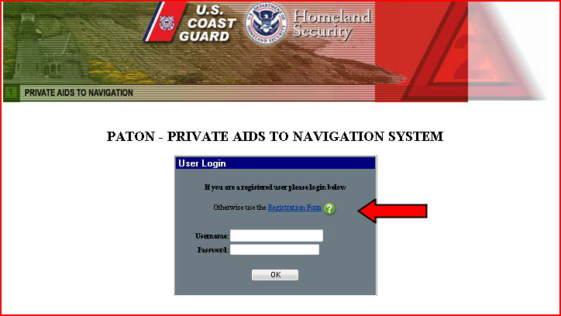

- HOW TO REGISTER

  - If you are not pre-registered on the PATON System, click on the words, “Registration Form” (Red Arrow) on the “User Logon Screen” to initiate the PATON Registration process. See example on page 3 above. The PATON Registration screen will appear. A sample PATON Registration screen is shown on page 5.

  - Fields designated with a red asterisk* are required. This means that you must enter information in this field.

3
Last Revised Oct. 13, 2020
Navigation Systems Division – Prevention, Accuracy, Credibility and Professionalism.
WEB-BASED PRIVATE AID TO NAVIGATION SYSTEM TRAINING GUIDE

- The field names are self explanatory. If you are unsure of what to enter in any field, click on the field’s “Question Mark” for further instructions. The instruction lasts for about six seconds.

- Note that the “State” field has a drop-down menu.

- Note to new registrants: Once you register, you will not be able to use the PATON system until your access code is approved by DPW 1 [Department Prevention Waterways] in Boston. You will receive an e-mail confirming your access codes when the approval process is completed.

- Additional USCG Auxiliary AV-Aid Verifier requirements: Qualified and current USCG Auxiliary Aid Verifiers should select “USCG Auxiliary” for their Type of User.” Selection is pointed out with a red arrow in the example on page 5.

This action causes an additional AV field to be added at the bottom of the PATON Registration screen, designated “DISTRICT/DIVISION/FLOTILLA.

Select your District/Division/Flotilla from the drop-down menu.

- Once you have completed and submitted your Registration Form, e-mail your DSO-NS. Advise the DSO-NS that you have registered on the PATON System.

Also indicate the CG ANT where you will be affiliated as an AV-Aid Verifier.

        - CG ANT S West Harbor
        - CG ANT South Portland
        - CG ANT Woods Hole
        - CG ANT Boston
        - CG ANT Bristol
        - CG ANT New York
        - CG ANT Saugerties
        - CG ANT Long Isl Sound
        - CG ANT Moriches
        - CG ANT Burlington.

If you are working for two CG ANTs, advise the DSO-NS. You will have to submit two registrations. The DSO-NS will guide you through the process.

- The DSO-NS checks whether you are AV Qualified and will approve and assign your access to the CG ANT that you selected. You will receive an e-mail confirming your access codes when this has been completed.

Note: You will not be able to log onto the PATON System until your access code has been approved. You will be e-mailed when the approval process has been completed by DPW 1.

- AVs will be assigned to the CG ANT AOR where they do their boating rather than where they live. This is called their affiliation. e.g. you live in New Hampshire but keep your OPFAC in Boston Harbor. Your CG ANT affiliation would be CG ANT Boston.

4
Last Revised Oct. 13, 2020
Navigation Systems Division – Prevention, Accuracy, Credibility and Professionalism.
WEB-BASED PRIVATE AID TO NAVIGATION SYSTEM TRAINING GUIDE

PATON Registration Screen Example
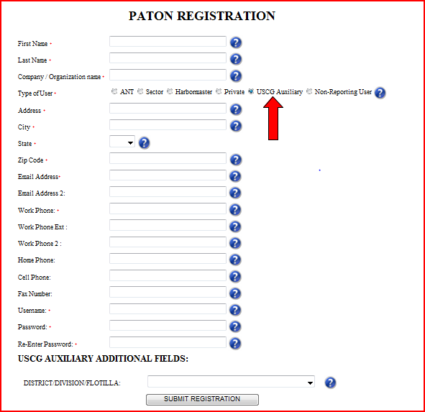

- IF YOU FORGET YOUR ACCESS CODE?

    - Auxiliarists: E-mail your DSO-NS.

- CHANGING YOUR REGISTRATION RECORD

  - E-Mail the DSO-NS in order to correct any fields in your PATON Registration Record.
  - Be specific as to the field(s) that you want changed and the data that you want changed in each field.

5
Last Revised Oct. 13, 2020
Navigation Systems Division – Prevention, Accuracy, Credibility and Professionalism.
WEB-BASED PRIVATE AID TO NAVIGATION SYSTEM TRAINING GUIDE

  - It is critical that any changes in status, telephone number and/or e-mail address be reported in a timely manner. Once you change your e-mail address without correcting the PATON Registration system, you will lose access to the PATON System.

- PREPARING A PATON APPLICATION – CG 2554

  - After you log-in, click on the word “Application” at the top of the AV LOGON screen. This button is identified with a red arrow in the example below.

  - The Private Aid to Navigation CG 2554 – PATON Application Screen will appear. Sections of this form appear starting on page 7 with explanations for its particular use.

  - The field names should be self explanatory. Click on the field’s “Question Mark” for additional instructions, if needed. There is a six second time limit on viewing instructions.

Header Section for a PATON Application CG 2554 Screen:

- Fields designated with a red asterisk * are required. You must enter information in these fields.

- Some fields will be pre-populated with data from your Registration Record. You are able to change this data. However, your Registration record will not be changed by this action. It is recommended that you change your Registration Record first.

PATON Logged On Screen Example
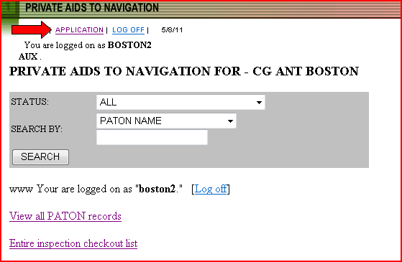

6
Last Revised Oct. 13, 2020
Navigation Systems Division – Prevention, Accuracy, Credibility and Professionalism.
WEB-BASED PRIVATE AID TO NAVIGATION SYSTEM TRAINING GUIDE

CG-2554 - Header Field Group Example.
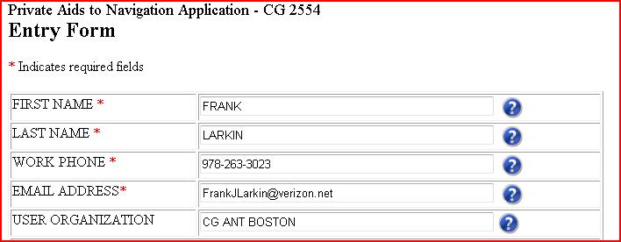

The data in these fields has been retrieved from the AV’s Registration Record.

Location, Depth and PATON Identification Section:

- The field names are self explanatory. Some fields have drop-down menus which control the data that can be entered in the field.

- The PATON TYPE field has optional bullets that, when selected, cause additional data field groups to be added to the CG2554 PATON Application.

  - Floating is the alternative to Fixed.

  - Lighted is the alternative to Unlighted.

CG-2554 – Location, Depth and PATON Type Example
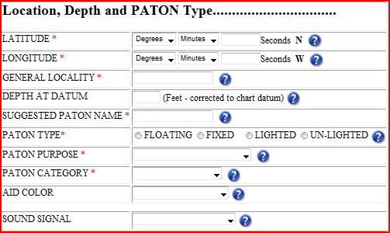

7
Last Revised Oct. 13, 2020
Navigation Systems Division – Prevention, Accuracy, Credibility and Professionalism.
WEB-BASED PRIVATE AID TO NAVIGATION SYSTEM TRAINING GUIDE

- Most of the fields in this report are equipped with drop-down or bulleted menus to control the data entered in these fields.
- Explain all “Other” selections in the Permit Application Comments Section on this screen.

- Report LAT and LONG as Degree, Minutes and Seconds formatted as:

DD-MM-SS.SS.

The Floating PATON Data Field Group

- When you designate a PATON TYPE as floating, a field data group of three additional fields appear as is demonstrated in the example below.

- Floating is the alternative selection to Fixed.

- The three fields in this data group are required when the PATON is designated as a floating aid. The ‘Buoy Material’ field has a drop down menu.

CG 2554 Floating PATON Data Group Example.
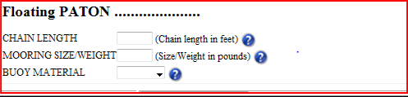

The Fixed PATON Data Field Group

- When you designate a PATON TYPE as fixed, a field data group of three additional fields appears as is shown in the example below.

- Fixed is the alternative selection to Floating.

- These three fields in this data group are required when the PATON is designated as a fixed aid. The ‘Aid Structure’ and ‘Structure Material’ fields have drop-down menus.

- All fixed PATONs, that are located in the water, must also have a Corps of Engineer’s (USACE) permit reference before the Coast Guard can approve and issue a permit.

CG 2554 Fixed PATON Data Field Group Example
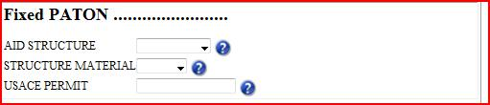

The Lighted PATON Data Field Group

- When you designate a PATON TYPE as lighted, a data group of four additional fields appears as is shown in the example below. Lighted is the alternative selection to Unlighted.

8
Last Revised Oct. 13, 2020
Navigation Systems Division – Prevention, Accuracy, Credibility and Professionalism.
WEB-BASED PRIVATE AID TO NAVIGATION SYSTEM TRAINING GUIDE

- The first three fields are required for all PATONs designated as Lighted.

- Fixed lighted PATONS must show the height of the light. Click on the Question Mark for instructions for measuring the height of a light correctly.
- Floating lighted PATONs do not require a “Height of Light” entry.

- The ‘Light Characteristic’ and ‘Light Color’ fields have drop down menus.

CG 2554 - Lighted PATON Data Field Group
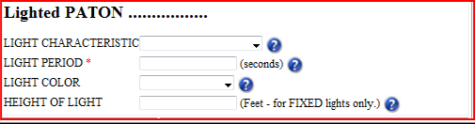

The Unlighted PATON Option

- Selecting “Unlighted” as a PATON TYPE field removes the “Lighted PATON data field group” from the PATON Application Screen. Unlighted is the alternative selection for lighted.

Establishment – Action Required and Duration

- There are four options for ‘Action Required’ – Annual, Seasonal, Temporary and Disestablish. Click on the Question Mark for an explanation of each option.

CG 2554 - Establishment Requested Field Group Section Example
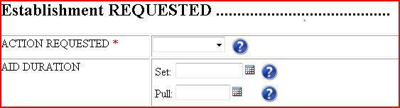

- Each Establishment option has a different duration requirement. Duration is the time period that an established PATON is deployed during the year.

- Annual indicates that the PATON is deployed all year round. Duration dates are not required.

- Seasonal indicates that the PATON is deployed at specific times during the year. A Set and Pull date is required with this option.

- Temporary indicates that the PATON is deployed for a fixed period of time.

- Duration can also represent the date when the aid will be dis-established.

- Click on the Question Mark to review the details for each Duration requirement.

9
Last Revised Oct. 13, 2020
Navigation Systems Division – Prevention, Accuracy, Credibility and Professionalism.
WEB-BASED PRIVATE AID TO NAVIGATION SYSTEM TRAINING GUIDE

Comments
- Enter any comments needed to explain any menu selections of “Other” or any feature that is not included in the standard permit fields.

- These comments may become part of the PATON’s permanent permit specification.

CG 2554 Comments Example
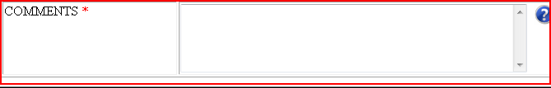

Submit Application:

  - Click on the “Submit Application” button to transmit the PATON Application to DPW 1 for processing and approval.

- Color Key Tracking System

  - The PATON Application Approval process can be tracked on line. Each step in the process is indicated by a color code. System Color Codes are described below.
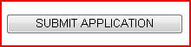

Color Key Tracking System Codes
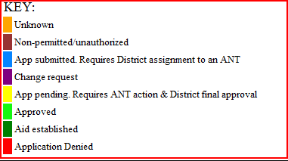

- You can track the status of your application through the approval process by referencing the color code assigned to the aid’s record. Color codes appear at the extreme left on the PATON listings.

  - Light Blue – means the PATON application has been received and is pending action by DPW 1.

  - Yellow – means the PATON application is being approved by the CG ANT and/or the Harbormaster.

  - Light Green – means that the PATON application has been approved.

10
Last Revised Oct. 13, 2020
Navigation Systems Division – Prevention, Accuracy, Credibility and Professionalism.
WEB-BASED PRIVATE AID TO NAVIGATION SYSTEM TRAINING GUIDE

- Dark Green – means that you have notified DPW 1 that you have established the aid (deployed the aid).

Permit Cancellation Guidelines:

PATON Permits may be cancelled when:

- The aid is not established (set out) within a one-year window,

- The aid is missing for two-consecutive years.

Check the “Permitted Comments” section for special notes regarding these issues.

- ACCESS TO PATONS

    - Once your access code is approved and you log onto the Web-Based PATON System, a list of the Private Aids to Navigation assigned to your linked affiliation will appear on the “Private Aids to Navigation Screen.”

PATON Owners – Will see the PATONs that they own. DPW 1 – Will view all PATONs.

CG ANT – Will view all PATONs assigned to their AOR.

- PRIVATE AID TO NAVIGATION SCREEN

  - This is the screen that appears when an AV logs on to the PATON System.

  - The screen shows your “Username.” It appears after the phrase, “You are logged on as:” e.g. boston1.

  - The title (in the example presented below) shows the CG OPFAC that you are logged on. e.g.

PRIVATE AIDS TO NAVIGATION FOR - CG ANT BOSTON.

Note: A CG OPFAC is a Coast Guard facility, such as Cg ANT Boston. It is not an Auxiliary vessel.

- To see the entire list of PATONs managed by the CG ANT, click on “View all PATON records.”

Private Aid to Navigation Screen Example
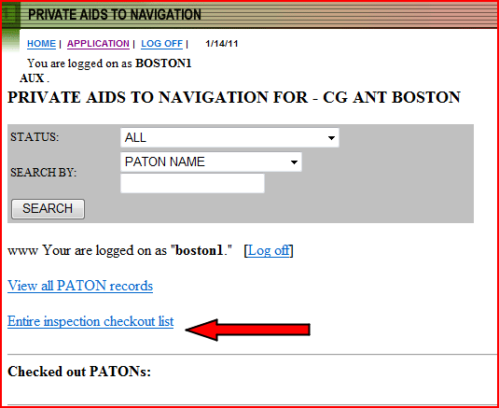

11
Last Revised Oct. 13, 2020
Navigation Systems Division – Prevention, Accuracy, Credibility and Professionalism.
WEB-BASED PRIVATE AID TO NAVIGATION SYSTEM TRAINING GUIDE

If your Division or CG ANT does not use the Check Out feature, ignore the next section and skip to “View all PATON records” on page 13.

- THE “CHECK OUT PATON LIST” FEATURE:

  - The System lists all of the PATONs that are identified as “YES” in the “Annual Verification “field and have not yet been verified during the current year.

    - A “YES” in the “Annual Verification” field puts the PATON on the “Check Out List.” The PATON will appear on the “Check Out List.” See example below.

    - A “NO” in the “Annual Verification” field removes the “YES.” The PATON will not appear on the “Check Out List.”

  - As PATONs are verified during a year, the system removes them from the “Check Out List.”

“Check Out List” Example
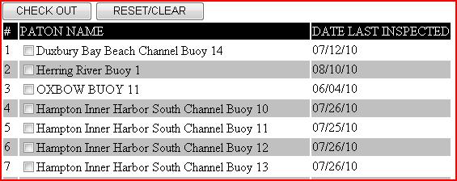

- Items that appear on the “Check Out List” can be checked out or reserved by a specific AV.

  - This means that the system will reserve the checked out aid to the AV for a two-week period. The PATON will appear on the “Checked Out PATON List” during the two-week time window. It will not appear on the “Check Out List” during that period.

  - If the checked out PATON is not reported as verified within the two-week time window, the system will return it to the Check Out list.

- To change a PATON from using the “Check Out” feature, a “NO” must be inserted in the Annual Verification field.

- Uses for the PATON Check Out feature:

  - It can be used as a scheduling technique to identify PATONs for verification in the current year. e.g. The POC pre-selects one/third of the PATONs for a particular year.

  - It can be used as a reservation technique in areas where there is contention by AVs for the same set of PATONS.

12
Last Revised Oct. 13, 2020
Navigation Systems Division – Prevention, Accuracy, Credibility and Professionalism.
WEB-BASED PRIVATE AID TO NAVIGATION SYSTEM TRAINING GUIDE

  - It can be simply used as a means to flag a specific PATON for special verification that has not yet been reported during the current year.

- Note: Once a PATON is verified within a current year, the PATON cannot be returned or re-used with the Check Out feature.

- Caution: PATONs flagged with a “YES” in the Annual Verification field will continue to be included on the “Check Out List” in each subsequent year until a “NO” is inserted in the Annual Verification field.

How to Check Out a PATON:

a. Items on the Check Out list are available for verification.

Example of Check Out Box.
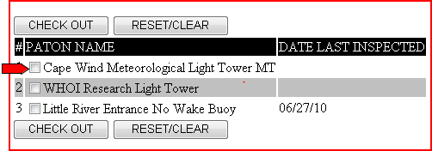

- Click on the box at the left of the PATON that you want to “check out” for verification. See the red arrow above.

- Click on the CHECK OUT box to add the PATON to the CHECKED OUT PATON LIST as displayed below.

- When you click on the “Entire inspection checkout list,” you will be able to view all of the PATONs that have been checked out for your CG ANT AOR.

Example of “Entire Inspection Check Out PATON List.
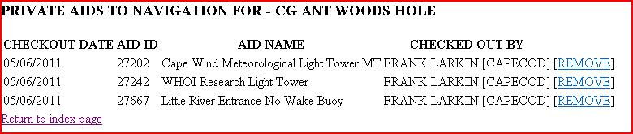

e. Click on the [REMOVE] box at the far right to return the PATON to the Check Out list.

13
Last Revised Oct. 13, 2020
Navigation Systems Division – Prevention, Accuracy, Credibility and Professionalism.
WEB-BASED PRIVATE AID TO NAVIGATION SYSTEM TRAINING GUIDE

- VIEW ALL PATON RECORDS
- When you click on “View all PATON Records,” all of the PATONs listed for the CG ANT will appear.

- This process may take a long time depending on the number of PATONs on the list. A sample report appears below.

- The initial PATON list should be sorted in alphabetical order.

- You can sort this list by any of the fields by clicking on the header field name.

- An example of the Standard PATON List is shown below.

Standard PATON List.
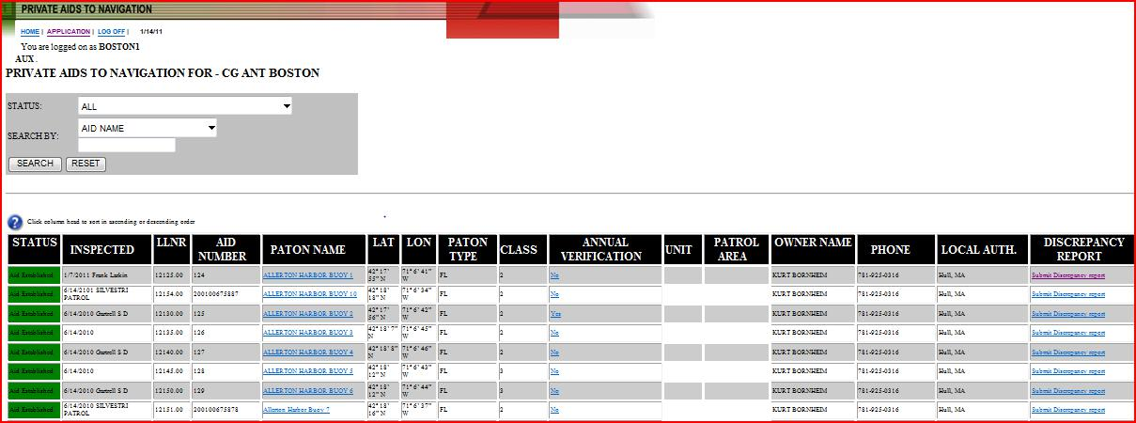

- SEARCH OPTIONS

You can sort for groups of PATONs using the “STATUS” command. Use the SEARCH BY drop down menu to sort the list of PATONS. Multiple options are available. The example below shows a sort option by PATON NAME.
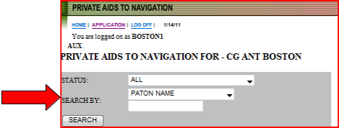


Since all aids have the name of the area or waterway as the front half of their description, enter this name in the blank field below the SEARCH BY field. “Dorchester” was selected in the example below.
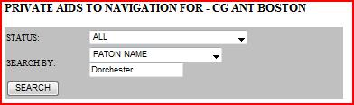

Click on the SEARCH box to view all of the PATONs with the word Dorchester in their description.

The example below shows that five records were found.

14
Last Revised Oct. 13, 2020
Navigation Systems Division – Prevention, Accuracy, Credibility and Professionalism.
WEB-BASED PRIVATE AID TO NAVIGATION SYSTEM TRAINING GUIDE
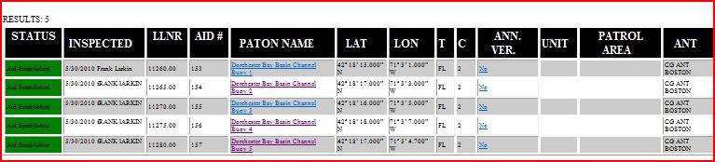

- THE EXCEL SPREADSHEET FEATURE

  - Open a blank EXCEL spread sheet on your computer.

  - Place the cursor at the top left hand side of the PATON list and drill down to the lower right hand side of the list that you want to copy.

  - Click on the blank EXCEL spreadsheet to generate your spreadsheet. See example below.

  - You are now able to manipulate the data on your spreadsheet any way that you want.

STATUS LLNR

^{Aid} 11280.00 Established

^{Aid} 11275.00 Established

^{Aid} 11270.00 Established

AID #

157
UPDATE

156
UPDATE

155
UPDATE

PATON

NAME
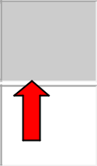

Dorchester Bay Basin Channel Buoy 5 x

Dorchester Bay Basin Channel Buoy 4 x

Dorchester Bay Basin Channel Buoy 3 x

LAT |  | LON |  | T |  | C |  | ANT |  | OWNER |  | EMAIL
42º 18’ |  | 71º 3’ |  |  |  |  |  |  |  | CG ANT
17.000” |  | 4.700” |  | FL |  | 2 |  |  |  | CG ANT |  | Frank Larkin
17.000” |  | 4.700” |  | FL |  | 2 |  |  |  | BOSTON
N |  | W |  |  |  |  |  |  |  | BOSTON
42º 18’ |  | 71º 3’ |  |  |  |  |  |  |  | CG ANT
18.000” |  | 7.000” |  | FL |  | 2 |  |  |  | CG ANT |  | Frank Larkin
18.000” |  | 7.000” |  | FL |  | 2 |  |  |  | BOSTON
N |  | W |  |  |  |  |  |  |  | BOSTON
42º 18’ |  | 71º 3’ |  |  |  |  |  |  |  | CG ANT
16.000” |  | 5.000” |  | FL |  | 2 |  |  |  | CG ANT |  | Frank Larkin
16.000” |  | 5.000” |  | FL |  | 2 |  |  |  | BOSTON
N |  | W |  |  |  |  |  |  |  | BOSTON

PHONE | LOCAL
PHONE | AUTH.

frankjlarkin@verizon.net ₉₇₈₋₂₆₃₋₃₀₂₃

frankjlarkin@verizon.net ₉₇₈₋₂₆₃₋₃₀₂₃

frankjlarkin@verizon.net ₉₇₈₋₂₆₃₋₃₀₂₃

Use the “return arrow” usually found at the top left-hand side of the screen to return to the full PATON file listing. This will avoid excessive waiting time while the system regenerates the complete file. Sometimes, you may get logged off the system.

15
Last Revised Oct. 13, 2020
Navigation Systems Division – Prevention, Accuracy, Credibility and Professionalism.

WEB-BASED PRIVATE AID TO NAVIGATION SYSTEM TRAINING GUIDE

13. THE ONE PAGE PATON VERIFICATION REPORT
- It is a good practice to download the ‘One-Page PATON Verification Report’ by clicking on a PATON NAME to view this report. See the example with the red arrow above. This report will contain the Official Image photo for the PATON.

- Print out a copy of the One Page PATON Verification Record to use while on-scene when you are verifying the private aid to navigation. Use the print both sides option to save paper when the aid has an Official Photo.

One of the AV’s responsibilities when verifying a PATON is to check whether any pertinent permit data is missing and to report the observed data on the 7054 AV Verification Report either by entering the correct data in the field and show it in the AV Observation section.

- The One-Page PATON Verification Record shows what information is currently in the PATON’s record so you can readily suggest corrections based on your on-scene observations. Use this form for recording your observations while on scene at the PATON.

This form also shows the Official Image Photo for the aid, when available.

A typical One Page Verification Report is shown below. This example shows an Official Image photo for the PATON.
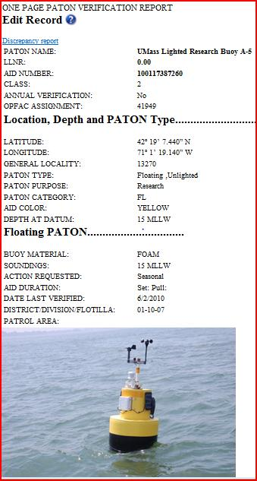

16
Last Revised Oct. 13, 2020
Navigation Systems Division – Prevention, Accuracy, Credibility and Professionalism.
WEB-BASED PRIVATE AID TO NAVIGATION SYSTEM TRAINING GUIDE

- PREPARING YOUR 7054 AV VERIFICATION REPORT FOR SUBMISSION TO THE COAST GUARD UNIT.

  - Click on the “Submit Discrepancy Report” field that is located at the far right end of a PATON listing. A sample screen is shown below.

  - The principal activity for the 7054 AV PATON Report is for notating any observed changes to the permitted specifications for the PATON and to list all observed discrepancies.

  - Only enter data in a PATON specification field when your on-scene

observation differs from the data shown in the left-hand column labeled “Permitted.” Otherwise, leave the field blank.

- A blank field is indication that you agree with the permitted shown on the report.

- Click on the Question Mark after the field to review the instructions for entering data in the field. The instruction will appear for six seconds.
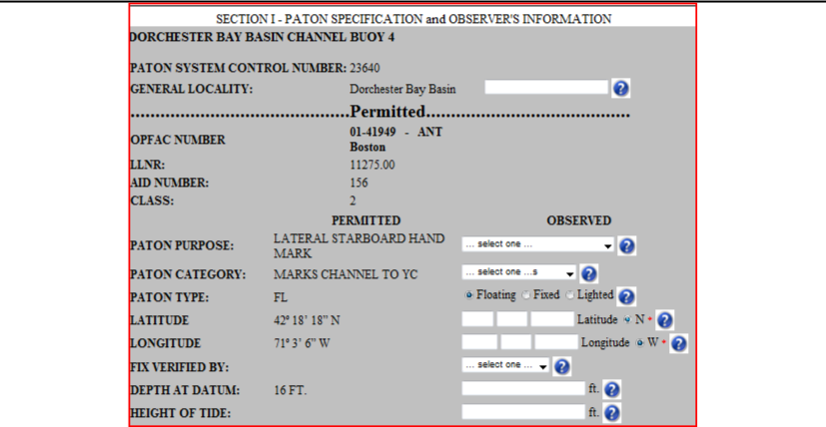

17
Last Revised Oct. 13, 2020
Navigation Systems Division – Prevention, Accuracy, Credibility and Professionalism.
WEB-BASED PRIVATE AID TO NAVIGATION SYSTEM TRAINING GUIDE

Criteria for reporting PATONs off station.

Determining whether a PATON is considered as off its permitted station has been a problem for many AVs. To resolve this issue, the following guide has been prepared to assist the AV in this determination. Criteria and actions have been established for three types of PATONs – Fixed PATONs, Floating Lateral PATONS and Floating Regulatory (non-lateral) PATONS. Each has a difference course of action.

- Fixed PATONs are permanently affixed to the earth. Determine whether an aid is off-station by using the following criteria.

  - Criteria:

    - The observed fix does not match the permitted Lat/Long exactly.

NOTE: Take into account the distance of the GPS receiver from the fixed aid. It is often difficult to get close to the aid due to riprap, shoaling or current. Remember, the lat/long that the GPS is producing is originating from the location of the GPS’ antenna or, when the antenna is self contained, from the position where the GPS is mounted on the OPFAC. Also consider the EPE error that is being recorded at the time when the fix was taken. It is a good practice to use a hand held GPS positioned as close to the fixed aid as possible.

Use this procedure for fixed aids and lateral aids only.

- When the aid is published in the Light List, the observed fix should also match the permitted Lat/Long and the Lat/Long in the Light List.

There also can be discrepancies between the permit record, the Light List and or the NOAA chart. Report these as documentation errors to DPW1.

- Additionally, when the aid is charted on a NOAA chart, the observed fix should match the permitted Lat/Long, the Lat/Long in the Light List and the Lat/Long for the aid on the NOAA chart.

- Be specific as to where the error has occurred – Permit, Light List or Chart or all three.

b. Action to take:

  - No action will be taken to correct a Lat/Long unless there is a valid Accuracy Statement included on the 7054 AV Verification Report. An Accuracy Statement provides evidence to support the accuracy and credibility of an AV’s observation.

  - Upon review of the 7054 AV Verification, the observed LAT/LONG should be forwarded by the CG ANT or ANT AV from the controlling CG ANT to DPW1 for correction.

- Follow up activity:

  - The assigned PAC should follow up with the ANT Auxiliary Liaison if update action is

18
Last Revised Oct. 13, 2020
Navigation Systems Division – Prevention, Accuracy, Credibility and Professionalism.
WEB-BASED PRIVATE AID TO NAVIGATION SYSTEM TRAINING GUIDE

not observed within two weeks through the CG ANT Auxiliary Liaison.

If the PATON is listed in the Light List, correction should be published in the LNM.

Note that NOAA uses the LNM in order to make the appropriate chart updates. The NOAA On-Line Chart Viewer will be digitally corrected within a week to 10 day period. This NOAA product is available on-line at www.uscgaan.com – click on “Helpful Links.”

      - I-ATONIS should be corrected by DPW.

      - This procedure applies to all fixed private aids.

- Floating Lateral PATONs are the aids that mark the edges of a navigable channel or fairway. Determine whether a lateral aid is considered off station by applying the following criteria.

    - Criteria:

        - When the aid is charted, an aid plotting outside the charted circle symbol for the Aid on the NOAA chart is reportable as off station. Indicate this condition in the AV Observation section.

        - When the aid not charted but published in the Light List, the Aid should be within 50 feet of the Permitted LAT/LONG.

  - Acton to take:

        - The actual position of a floating aid to navigation is the location of its anchor or mooring. The aid itself floats around the anchor in what is termed its “watch circle” when it is affected by wind and current.

        - AV observers should take every precaution to adjust the location where the fix is taken at the aid for the local affects of wind and/or current on the aid’s watch circle and, therefore, provide more accurate observations. This natural offset can be compensated by heading the vessel up wind and/or current a short distance to be closer to the aid’s anchor. This activity should be noted on the Accuracy Statement of the PATON Report.

Warning: In low water areas, do not perform this offset because of the danger of fouling your prop or striking the aid’s anchor. The prudent AV will only take fixes and depths at times of high water. Determine the possibility of shoaling by calculating the Depth at charted datum calculation. If the answer is negative, you have determines that the aid will strand or shoal at times of low tides.

- No corrective action can be taken unless there is a valid Accuracy Statement is included on your 7054 AV Verification Report.

- Upon review of the 7054 AV Verification, the observed LAT/LONG should be forwarded by the CG ANT or ANT AV from the controlling CG ANT to DPW for correction.

19
Last Revised Oct. 13, 2020
Navigation Systems Division – Prevention, Accuracy, Credibility and Professionalism.
WEB-BASED PRIVATE AID TO NAVIGATION SYSTEM TRAINING GUIDE

      - The NS-CU07 Vertical and Horizontal Error Calculator can also be used. This tool is available on the Chart Updating Web Page at www.uscgaan.com. An example is shown on page 21.

  - Follow up activity:

    - The assigned PAC should follow up with the ANT Auxiliary Liaison if update action is not observed within two weeks through the CG ANT Auxiliary Liaison.

DPW should publish corrections in the LNM for PATONs that are listed in the Light List.

NOAA references the LNM to make the appropriate chart updates. The NOAA On-Line Chart Viewer will be digitally corrected within a week to 10 day period. This NOAA product is available on-line at www.uscgaan.com – click on “Helpful Links.”

    - I-ATONIS is corrected by DPW.

    - This procedure applies to all private floating lateral aids.

- Floating Regulatory and Special Purpose PATONS
- Criteria:

  - AV would report an aid off station when the fix is 500 feet or more from the aid’s permitted position.

- Action to Take:

    - No action can be taken unless there is a valid Accuracy Statement included on the 7054 AV Verification Report.

  - Upon review of the 7054 AV Verification, the observed LAT/LONG should be forwarded by the CG ANT or ANT AV from the controlling CG ANT to DPW for correction.

- Follow up Activity:

  - PATON permitted data should be corrected by DPW to match the observed Lat/Long.

  - I-ATONIS is corrected by DPW.

20
Last Revised Oct. 13, 2020
Navigation Systems Division – Prevention, Accuracy, Credibility and Professionalism.
WEB-BASED PRIVATE AID TO NAVIGATION SYSTEM TRAINING GUIDE

You can use the Distance Standards below to estimate the distance off.

DISTANCE STANDARDS

One degree of Latitude | [ 01-00-00-00 ] | 60.8 nm
One Nautical mile or 1 minute of Latitude | [ 00-01-00-00 ] | 6,076 ft
One Second of Latitude | [ 00-00-01.00 ] | 101.3 ft
One-tenth of a second of Latitude | [ 00-00-00.10 ] | 10.1 ft.
One-hundreth of a second of Latitude | [ 00-00-00.01 ] | 1.0 ft.

21
Last Revised Oct. 13, 2020
Navigation Systems Division – Prevention, Accuracy, Credibility and Professionalism.
WEB-BASED PRIVATE AID TO NAVIGATION SYSTEM TRAINING GUIDE

Documentation Discrepancies
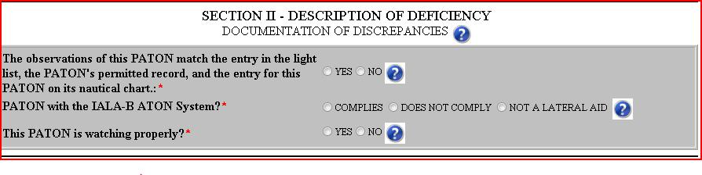

You must respond to these three required questions regarding the condition of the PATON that you are observing.

- The first question deals with the documentation of the aid versus your on-scene observation of the aid. This is a required question.

  - Comparison of the on scene observation versus the data on the permitted record.

  - If listed in the Light List, comparison of the on-scene observation versus the permitted record and the data shown in the Light List for the aid.

  - If also charted, comparison of the on-scene observation versus the permitted record and the data shown in the Light List and also the charted lat/long and the symbols and abbreviations for the aid on the NOAA chart.

You can only respond with a “Yes” when all these factors are in sync.

NOTE: Matching the IALA-B System involves the shape, color, marking and retro-reflective material observed on the aid.

- The second question deals with whether the aid corresponds to the IALA-B Aid to Navigation System. The IALA-B system only deals with lateral aids – aids that mark navigational channels or fairways. This also is a required question.

NOTE: Lighthouses are not considered lateral aids.

  - When the aid is not a lateral aid, check off, “Not a Lateral Aid.”

  - When the aid is a lateral aid and it matches the IALA-B system, check off, “Complies.”

  - When the aid is a lateral aid and it does not match the I-ALA B system, check off, “Does not comply.” Attach a discrepancy photo to your report to demonstrate how the aid is not in compliance and explain in the AV Observation section on the 7054 AV Verification Report.

- The third question deals with whether the aid is watching properly. This also is a required question.

  - The standard lists of discrepancies do not appear on the 7054 AV Verification Report until you respond with a “NO” to this question.

22
Last Revised Oct. 13, 2020
Navigation Systems Division – Prevention, Accuracy, Credibility and Professionalism.
WEB-BASED PRIVATE AID TO NAVIGATION SYSTEM TRAINING GUIDE

- Be sure to read the “Watching Properly” criteria below to be positive that you understand the ramifications for answering this question correctly.

Read this before reporting an aid as

“Watching Properly”

Answering YES or NO to the question, “AID IS WATCHING PROPERLY,” on a PATON Report has very important ramifications to the person reviewing your report. When you respond with a “YES,” you are, in effect, certifying that everything about this Private Aid is absolutely perfect.

Note: The 7054 AV Verification Report will not show the standard list of discrepancies unless you respond with a ‘NO’ to the question, “This PATON is watching properly?”

Here are some important criteria that are being assumed by the CG ANT and DPW1 when you report an aid as watching properly:

- You are certifying that there are no permit specification errors on the aid. In other

words, the permit specifications on the “One Page Verification Report” match the on- scene observation about the PATON. The most current permit specifications appear at the left-hand side of the 7054 PATON Verification Report screen, under the heading, “Permitted.”

- You are certifying that you have not observed any physical discrepancies on the

aid. In other words, the aid has all of its numbers or letters, the shape is right and if lighted, the light color is correct, the light is operating to its specified characteristic and light period, and the aid is not off station and is marking the best water.

- When a PATON is listed in the Light List, you are certifying that the data in the Light List describes this aid perfectly as you viewed it while on-scene.

- When an aid is charted, you are certifying that the charted position is exact on the chart. See the guidelines for reporting a PATON off station. You are also certifying that the symbols and abbreviation on the chart are correct and reflect your on-scene observation and the entry for the aid in the Light List.

- When the PATON is a lateral aid, you are certifying that the aid conforms to the IALA-B Aid to Navigation System- - correct color, shape, numbering and retro-reflective material.

- When the PATON is a regulatory buoy, you are certifying that it conforms to the standard marking specified for a Regulatory Buoy – a white aid with two orange bands and black lettering and symbols. This is reported even when the PATON record specification has a different specification. Commonly, these aids are used for marking swim areas, no wake and speed zones, hazards, exclusion areas, etc.

- When the aid is used for a special purpose, you are certifying that it is yellow. These aids typically mark mooring area boundaries, aquaculture facilities and aids, sail race marks, etc.

Check the aid out on the NOAA on-line Chart Viewer which you can access from the “Helpful Links” page on the Navigation Systems web site at www.uscgaan.com.

23
Last Revised Oct. 13, 2020
Navigation Systems Division – Prevention, Accuracy, Credibility and Professionalism.
WEB-BASED PRIVATE AID TO NAVIGATION SYSTEM TRAINING GUIDE

NOAA updates these on-line charts within a week to ten days from when the aid correction appeared in the LNM-Local Notice to Mariners.

Reference the LNM viewing feature that is shown at the top right-hand corner of this chart screen for the latest LNM update information.

NOAA updates their on-line charts digitally whenever corrections are published in the Coast Guards LNM-Local Notice to Mariners.

Paper NOAA charts are corrected only when they are re-released and re-printed.

Using the NOAA on-line Chart Viewer as a reference will save you a lot of time keeping your paper charts corrected.

- When the aid is charted, you need to plot your observed fix and check whether the aid is positioned on or off station on a NOAA chart.

This is an important part of a lateral aid check but is not required for a regulatory aid check. Regulatory aids are only problematic when they are deployed within a navigable channel. Most regulatory aids are not charted nor listed in the Light List.

When the charted position differs from the Light List and the PATON is charted, your 7054 PATON Verification Report that initiates a LNM will correct the NOAA chart.

Use the NS-CU07 Vertical and Horizontal Error Calculator which is available on the Chart Updating Web Page on the D1NR Navigation Systems Web Site at www.uscgaan.com. This tool will calculate and report the number of feet an aid is off station and the True direction from the permitted Lat/Long. If you enter a complete set of data, it will compute a watch circle radius for the PATON. You also can enter your distance of the PATON and your EPE which will be taken into account in the calculation of the feet off station calculation.

- If you are not sure whether a problem exists or not, contact your POC, your ADSO-NS or

the DSO-NS.

DESCRIPTION OF DEFICIENCY

Check off each discrepancy that you observe on the aid. The discrepancy name should be self explanatory once you read the Training Guides. Discrepancy fields do not appear until you respond with a “NO” to the question, “Aid is Watching Properly?” on the 7054 AV Verification Report.

24
Last Revised Oct. 13, 2020
Navigation Systems Division – Prevention, Accuracy, Credibility and Professionalism.
WEB-BASED PRIVATE AID TO NAVIGATION SYSTEM TRAINING GUIDE
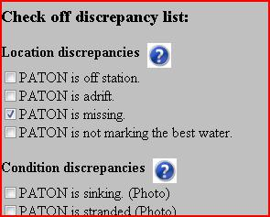

Each discrepancy that you check will be reported to the CG ANT when you submit your report.

NOTE some discrepancies may be confusing or contain multiple meanings. In these cases, always explain your exact meaning in the “AV Observations” section on your report.

PERMITTED COMMENTS

Permitted comments are reserved for explanations about fields in the PATON application only.
Data cannot be entered in this field from the 7054 AV Verification Report. It is reference only.
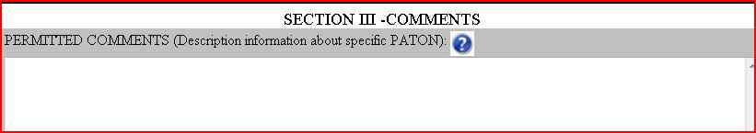

AV OBSERVATIONS

Always include any explanations that improve the clarity and credibility of your evidence about any problem(s) reported about a PATON.

IMPORTANT: If you have previously reported discrepancies about a PATON and it appears that no action has been taken to correct the situation, indicate the details of the problem in the AV Observation section. Also indicate how long this problem has existed and when you previously reported it. This is very important when reporting missing aids. PATON permits may be cancelled for aids missing over two years. Always quote credible and official sources.

As an AV or PAC, take the condition of the PATONs in your assigned Patrol Area seriously. Insist that corrective action be taken and that you get a response as to the reason why not, especially when the problem has persisted for many years.

In some situations, the CG ANT may need assistance to keep up with the backload of reported problems. Volunteer to assist the ANT with this backload. We are all on the same team.

25
Last Revised Oct. 13, 2020
Navigation Systems Division – Prevention, Accuracy, Credibility and Professionalism.
WEB-BASED PRIVATE AID TO NAVIGATION SYSTEM TRAINING GUIDE
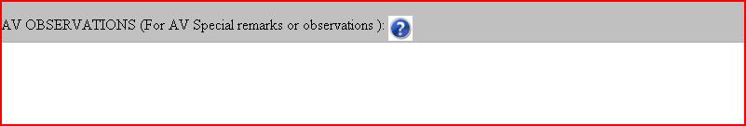

STANDARDIZED ACCURACY STATEMENT

This standardized accuracy statement shows that you have checked and identified that all electronic equipment that you are using is working correctly before you got underway and shows the quality of the fixes and depths while on-scene at the PATON. This statement is a reflection of the accuracy and professionalism of the AV’s report.

This Standardized Accuracy Statement provides the following:

Data about the GPS(s) used to take the reported fix:
- The manufacturer’s name and model number of the GPS used to take the fix.
- EPE-Estimated Position Error or HDOP-Horizontal Dilution of Position reading on your GPS when the fix was taken.
- How you pre-calibrated your GPS before getting underway.
- Whether your GPS was operating in 3D or 3D Differential when the fix was taken.
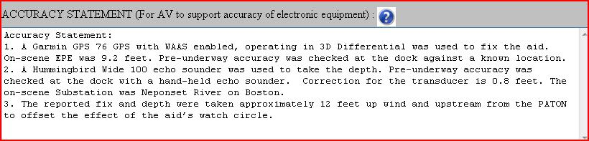

This Standard Accuracy Statement provides the following:

Data about the GPS(s) used to take the reported fix:
- The manufacturer’s name and model number of the GPS used to take the fix.
- EPE-Estimated Position Error or HDOP-Horizontal Dilution of Position reading on your GPS when the fix was taken.
- How you pre-calibrated your GPS before getting underway.
- Whether your GPS was operating in 3D or 3D Differential when the fix was taken.

Data for the echo-sounder used to record the depth:

- The model number and manufacturer’s name of the echo sounder.
- How you calibrated the echo sounder to ensure that it was operating correctly.
- Indicate the date and time when the depth was taken. The “Time When Reported” is assumed to be the time when the depth was taken unless you show a different date in your “Accuracy Statement” or in the “AV Observations.”

26
Last Revised Oct. 13, 2020
Navigation Systems Division – Prevention, Accuracy, Credibility and Professionalism.
WEB-BASED PRIVATE AID TO NAVIGATION SYSTEM TRAINING GUIDE

USING THE STANDARDIZED ACCURACY STATEMENT

- An Accuracy Statement similar to the example provided below enhances the professionalism and credibility of your verification report. You will be recognized as a professional by the Coast Guard. It is quick and easy to prepare this statement when you follow the example shown below.

- Prepare a “copy and paste” statement entry on your desktop for the standard statements below. It can be copied from this guide or can be downloaded from the Navigation Systems web site at www.uscgaan.com.

- The fields highlighted in yellow have to be set only once for your OPFAC or whenever you use a different OPFAC for a patrol.

- The fields highlighted in green have to change for each PATON.

- Leave the highlights in your desktop report as a reminder. The PATON System removes these highlights when the statement is pasted into the Accuracy Statement field on the on-line 7054 PATON Verification Report.

STANDARDIZED ACCURACY STATEMENTS Standardized Statement for a Floating Aid:

ACCURACY STATEMENT:

- A Garmin GPS 76 GPS with WAAS enabled, operating in 3D Differential was used to fix the aid. On-scene EPE was 9.2 feet. Pre-underway accuracy was checked at the dock against a known location.
- A Hummingbird Wide 100 echo sounder was used to take the depth. Pre-underway accuracy was checked at the dock with a hand-held echo sounder. Correction for the transducer is 0.8 feet. The on-scene Substation was Neponset River on Boston.

- The reported fix and depth were taken approximately 12 feet up wind and upstream from the PATON to offset the effect of the aid’s watch circle.

Standardized Statement for a Fixed Aid:

ACCURACY STATEMENT:

- A Garmin GPS 76 GPS with WAAS enabled, operating in 3D Differential was used to fix the aid. On-scene EPE was 9.2 feet. Pre-underway accuracy was checked at the dock against a known location.
- A Hummingbird Wide 100 echo sounder was used to take the depth. Correction for the transducer is 0.8 feet. Pre-underway accuracy was checked at the dock with a hand-held echo sounder. The on-scene Substation was Neponset River on Boston.

27
Last Revised Oct. 13, 2020
Navigation Systems Division – Prevention, Accuracy, Credibility and Professionalism.
WEB-BASED PRIVATE AID TO NAVIGATION SYSTEM TRAINING GUIDE PHOTOS OF PATONS.

Two types of digital photos can be reported on the PATON System – the Official Image photo of the PATON and photos of discrepancies observed on the PATON.

OFFICIAL IMAGE PHOTO of the PATON.

- This is a photo of the aid as watching properly. There should be no discrepancies appearing on the OFFICIAL IMAGE digital photo for a PATON.

- Label the photo with your Division Number, the LLNR or Aid Number and a brief description of the PATON. Do not use special characters or blank spaces. Underline is OK.

E.g. 06_12345-Back_Riv_3 would represent the #3 on the Back River in Division 6. The LLNR was used.

E.g. 03_20071436122_No_Wake would represent a No Wake Buoy in Division 3. In this case there is no LLNR so the Aid Number was reported.

- E-mail Official Image photos of a PATON to the DSO-NS.

- Be sure to include all of the PATON’s markings in your photo – number, retro, etc.

- An example of an Official Image photo can be observed on the ‘One Page Verification Report’ back on page 16 of this guide.

DISCREPANCY PHOTOS of a PATON

- The PATON System allows for the inclusion of multiple photos of discrepancies observed on a PATON on the on-line 7054 PATON Verification Repo

- The browser will appear as demonstrated below.

The Discrepancy Photo Browser.
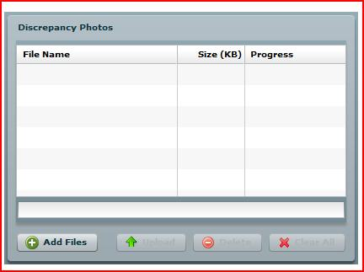

- Click on “ADD FILES” to browse your computer and select discrepancy photo(s). See sample below.

28
Last Revised Oct. 13, 2020
Navigation Systems Division – Prevention, Accuracy, Credibility and Professionalism.
WEB-BASED PRIVATE AID TO NAVIGATION SYSTEM TRAINING GUIDE
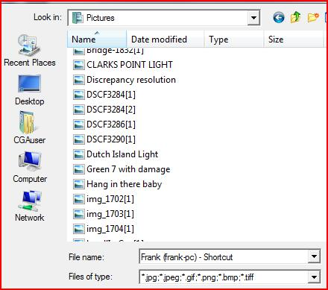

- Select the location where your PATON photos are stored. Click on the photo that you want to download and upload them to your verification report.
- You will be able to view the photos on the AV confirmation report – “Thanks for your Submission.”
- Note the discrepancies showing on this photo. The 7054 report, with photo, is sent to the owner as evidence of the discrepancy.
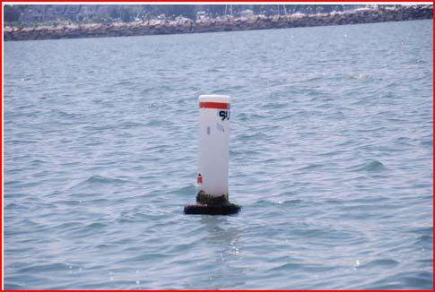

29
Last Revised Oct. 13, 2020
Navigation Systems Division – Prevention, Accuracy, Credibility and Professionalism.
WEB-BASED PRIVATE AID TO NAVIGATION SYSTEM TRAINING GUIDE

SECTION IV – AV Reporting

These three fields are retrieved from your Registration Record. This is the member submitting the 7054 report.
Submitted by
Division – Flotilla
Email Address

Important: Our Navigation Systems Programs get their recognition and support from your activity reports to AUXDATA. Help us stay funded by submitting these reports after each PATON Patrol.

- REPORTING YOUR ACTIVITY TO THE COAST GUARD AND AUXDATA

  - The “7054 AV Verification Report” transmits your PATON observations to your affiliated CG Unit when you click the ‘SUBMIT PATON REPORT’ button.

    - Copies are sent to the Owner, Sector, CG ANT, DPW-1, DSO-NS, and the person who submitted the 7054.

30
Last Revised Oct. 13, 2020
Navigation Systems Division – Prevention, Accuracy, Credibility and Professionalism.
WEB-BASED PRIVATE AID TO NAVIGATION SYSTEM TRAINING GUIDE

The CG ANT / Sector / AV PATON Report.

A copy of a typical report as it is received at the CG ANT is shown on page 33. A specification error was reported. The buoy material was ‘plastic’ instead of ‘foam.’ A depth error was also reported as a discrepancy. The standard Accuracy Statement was also reported in the ‘Accuracy Statement’ section.

Corrections to Permitted Specifications are performed by DPW1.

Review of the AV Comments is performed by the CG ANT AV Staff.

A sample report to the Coast Guard is shown on page 32.

Note: In the example below, the AV has entered only the permitted data that was observed as changed. The depth was the only observed change. AV entered the method used to take the fix and the HOT -Height of Tide for the time when the depth was observed. These entries enhance the credibility of the data in the AV’s report.

31
Last Revised Oct. 13, 2020
Navigation Systems Division – Prevention, Accuracy, Credibility and Professionalism.
WEB-BASED PRIVATE AID TO NAVIGATION SYSTEM TRAINING GUIDE
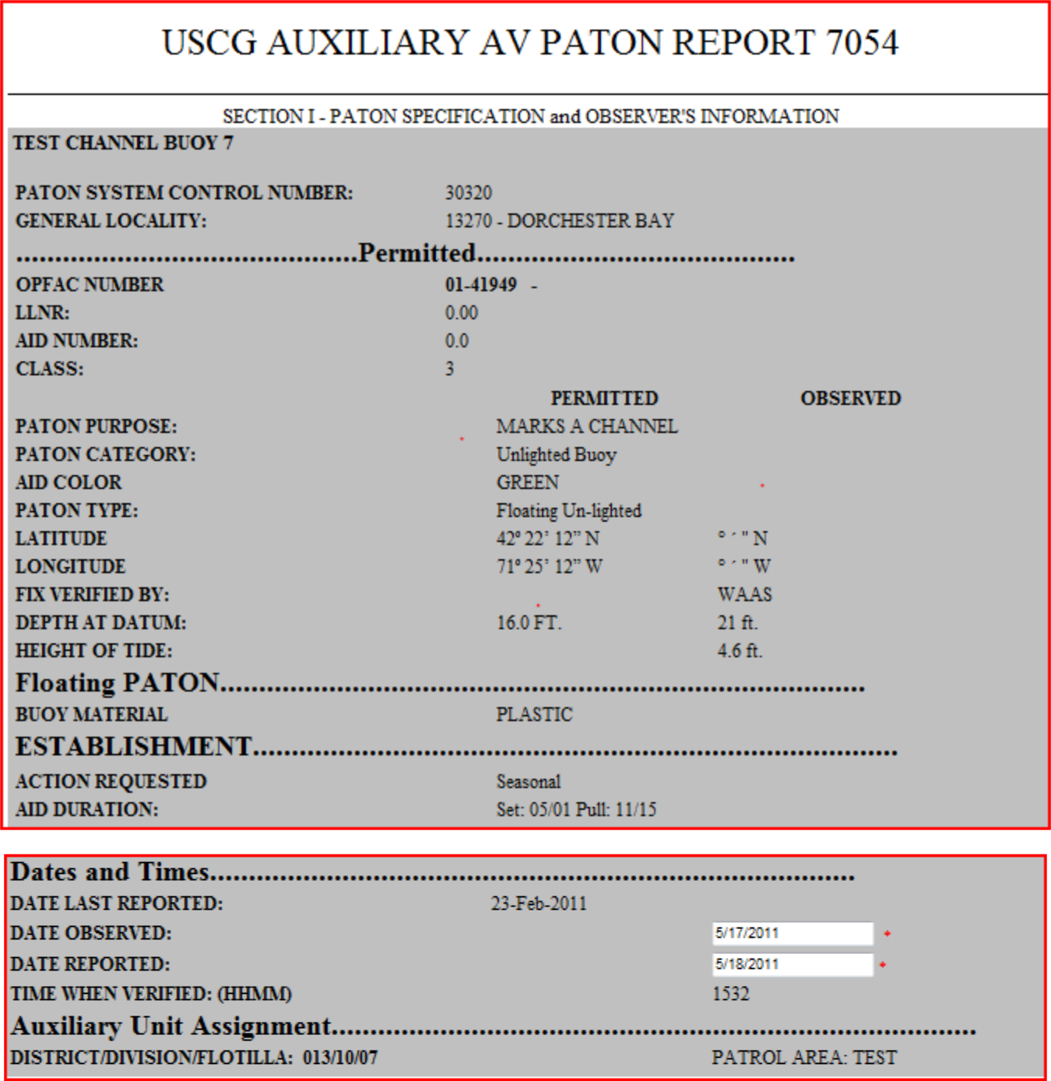

In the example above, the AV changed the Date Observed to reflect when the verification actually occurred. The aid was pre-assigned to a specific Division and a Patrol Area.

32
Last Revised Oct. 13, 2020
Navigation Systems Division – Prevention, Accuracy, Credibility and Professionalism.
WEB-BASED PRIVATE AID TO NAVIGATION SYSTEM TRAINING GUIDE
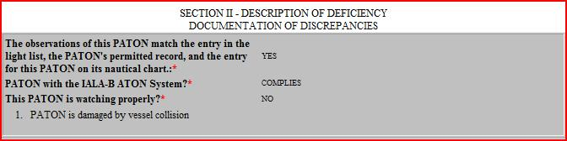

In the example above, these three fields are required by the AV and are explained above.
NOTE: The discrepancy that was checked by the AV appears in this section of this report.
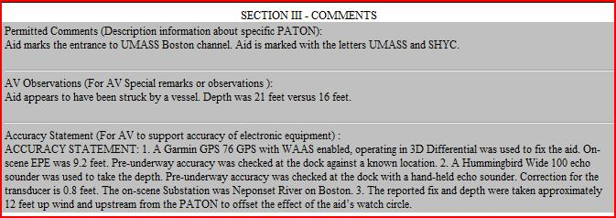

There are three distinct fields that make up the Comments Section.

Permitted Comments are generated from the Owner’s Permit Application and are for reference only on this report.

AV Observations are entered by the AV on the 7054 PATON Verification Report. This is the area where the report reviewer in the CG ANT and HQ focuses their attention for information about the verification report. This section is segregated from the others so that it will be easier to read the information provided by the AV regarding problems associated with the aid.

Accuracy Statement is submitted by the AV as evidence of the accuracy of the GPS and Echo Sounder used to gather electronic-generated data. This data is important for the credibility of the data submitted. Data submitted without this statement is considered suspect.

Discrepancy Photos are encouraged since they provide direct evidence of the discrepancy. Photos leave little doubt as to the nature and extent of the discrepancy

33
Last Revised Oct. 13, 2020
Navigation Systems Division – Prevention, Accuracy, Credibility and Professionalism

